**BAR-H**

**BUSINESS PLAN**

Paolo Mantovani

Giacomo Victor Massari

Francesca Mori

Martina Sangiorgi

**SUMMARY**

Business Overview 3

Market Opportunity 5

The Market Solution 7

The Market 9

Implementation Roadmap 11

Management Team 12

Financial Analysis 14

Social/environmental impact analysis 17

Risk Analysis 18

Funding 20

# **Business Overview**

BAR-H is a place created by students for students that conjugates the co-working space and the bar concept in a city where students’ needs are very often ignored. For this reason, we would like to place our bar near the Catholic University, in Gemelli Campus placed in Sant’Ambrogio (Milan), an area that we (as students) know very well.

To show our business idea, we are going to illustrate the vision and the aims we set through the business model.

Firstly, we can talk about our value proposition, which consists of creating a familiar and informal space for students which offers not only common bar services and entertainment but also additional solutions for students’needs from the more direct, quite place for studying, to the more specific, place where to take and deliver tutoring sessions and to take language lessons.

Regarding the customer target, we would like to focus on high-school and university students (17 – 30 y.o), who are very often exhausted by the constant research of a place where they can feel at home and concentrate, without the pressure of the traditional bar that doesn’t allow them to stay for long periods.

The only channel we have is the bar itself, through which we sell our products (classic bar products) and specific services, such as tutoring, language courses and rooms reservation for working groups.

To establish relationships with our customers we will develop a website for informative aims about the activities made in the BAR-H, social network pages for advertising purposes, and an app for booking tutoring sessions, joining events and for places reservation.

In our business, revenue streams will come from: bar services (café, bundles), commissions from tutoring, renting fees and commissions/earnings coming from small events we are going to organize.

Now let’s talk about our key partners: first, we’ll share a partnership with “Superprof”, an Italian platform of courses and private lessons that counts thousands of teachers and students; through this partnership we’ll give to our customers the chance to reserve these lessons through our App, with the advantage of using our studying space. Other partners we would like to have in a short time are two new projects aimed at reducing waste: the first, called “Re-Schiscia”, combines environmental sustainability, nice design and utility in a program made to eliminate waste giving the possibility to clients to take and eat their own “schiscia” in the bar; the second, called “Biova project”, which focuses on the using of old/unsold bread in the beer making process. We will also count on a local patisserie in order to have fresh products for breakfast, such as croissants and muffins.

Taking into consideration the key activities of our business, we have to mention the marketing campaign, which is very important to be known in the first years, the food and product selling, the rooms renting and the organization of small events, which allow us to be competitive also in the evening hours.

And what about our key resources? From a structural point of view our first key resource will be represented by the loft, so the place that we’ll make available for our customers; consisting of big tables, in order to guarantee a comfortable place and charging points for groups work or individual study. Then we must consider the raw materials and the facilities used to make bar products and services available. Lastly, the most important resource: ourselves! We have decided to work directly in the bar in order to be in touch with our young clients and create a familiar and friendly environment where feel at home.

In conclusion we have to mention our cost structure, which consists of fixed and variable costs: the first ones regard those costs which don’t depend on the produced volume, so in our case the loft rental cost, the salaries and the costs coming from the facilities, the licenses needed and the app and website development and maintaining. The variable costs instead, which depend on the production, are represented only by raw materials.

Let’s now say few words about the vision we have and the future of our project in a time lapse of approximately 5 years. Our dream is the opening of several spaces like this in Milan, for example near other universities, and generally speaking, in different cities populated by students. In parallel to this ambition, we would like to become a reference point for the youngest also in a more instructive way, implementing specific courses in different topics, from the language to the sustainability in everyday life.

In conclusion, we are going to talk about the current status of development of our project, for which we have already chosen the location, the team and we are waiting for the needed licenses. In relation to the first aspect, we chose the loft which was previously occupied by “Studio G”, a dancing school, in via San Vittore.

Regarding the financial aspect and in particular the funding sources, which will be better explained later, we decided to start with an initial capital of 300.000 euros. Since we are still students and we don’t have a regular income, we asked for some help to our families and for a loan from the bank. Having a financial availability of 50.000€, the equity will be equal to about 16,67% of the initial capital.

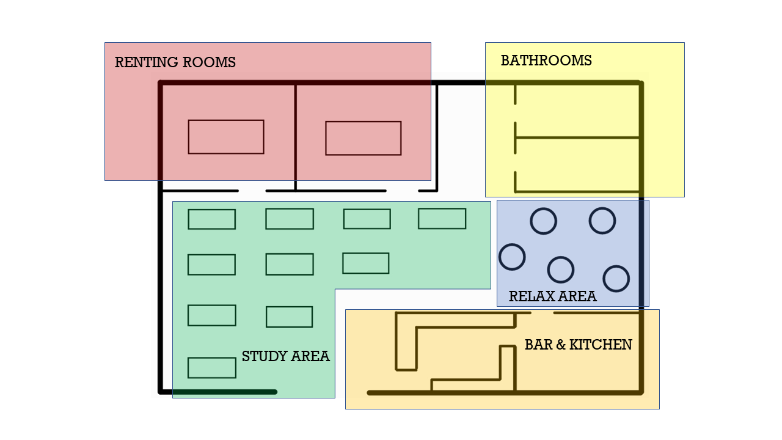

Figure 1 – floorplan of Bar-H

# **Market Opportunity**

The starting point is that we represent the main customer target in this situation, so we can consider our personal experience as students in search for a place to study outside the house or the school/university buildings.

This kind of bar could meet all those expectations belonging to students which until today are still not completely satisfied, at least not in a single place.

The main problem of a big city as Milan in fact, is that the general focus is on the portion of the population that doesn’t have the needs that a student has. In this case an average bar prefers to serve the customer segment of workers, who can use the offered services at least twice per day, from breakfast to lunch, and spend a shorter time there. In this framework students are constricted between the limited time that they are allowed to stay in without any constriction of consuming, and the limitation of a not sufficiently equipped workspace. Furthermore, during the weekend is very difficult to find a place where to study, also because many libraries are closed on Sunday.

From our point of view, in quality of students, we can state that the activity of studying outside and changing the usual environment is helpful in terms of focus and productivity. Especially for the foreign or offsite students having a place to study is very convenient, since it’s likely that they don’t have a comfortable workspace inside the house they rent or the college.

Finally, a good co-working space for students promote the level of sociability by stimulating the creation of work groups and through the organization of some funny events during the night.

Since we think about ourselves as the main customer target, we know very well that others bar/co-working spaces are not so interested in finding solutions in order to catch more students as clients for the reasons that we have explained above; starting from this, no bar is interested on upgrading its environment in order to satisfy a need that it doesn’t even think that exists.

Some examples of our main competitors are the following:

* Red Feltrinelli
* Academic and public libraries
* Starbucks
* CityLife
* Otto

Let’s start from thinking about a Bistrot which normally offers the possibility to study there during the day: “Red Bistrot”, belonging to the complex of “LaFeltrinelli”.

Formally, during the day, you can go there for studying and taking some food or coffee, but in practice there are some problems related to the time you can really spend there.

In fact, if you go there it’s pretty clear that their focus is on another target of customer instead of the students’ one; just think that if you go there from the early morning, you must take into account that from 11 a.m. waiters start telling you to move on and that they need to prepare all the tables for the lunch time, which lasts until 3 p.m. This represents a problem for us, since we lose time in order to change place.

The same happens even if you go there in the evening, since around 5/5.30 p.m. they ask you the same thing in order to prepare for happy hour. Furthermore, the tables available are really small most of the time and so not very comfortable.

A different situation is represented and offered by the City Life Shopping Center, where you can find several tables equipped with charging points and you don’t have to consume necessarily in order to study. Here you have also a great variety of restaurants and bars for your meals and breaks. However, it still is a shopping center and so it’s a noisy and chaotic place, above all during lunch and dinner time.

A better service instead is offered by the municipal libraries, where you can reserve your place and stay during the day without big problems; however, also here there are some problems related to the rooms temperature and to the absence of food/drink service.

Taking into account two of the most popular libraries in Milan, “Sormani” and “Valvassori Peroni”, we can see that there are some critical points: firstly, they normally close at 6 or 7 p.m., depending on periods, so too early for students who are on exams session; secondly, rooms are so cold in winter that students have to keep on their jackets, which is not really comfortable during a study session.

Even if we think about academic libraries, there are some problems in terms of available places: for example, at Catholic University we have very few tables for project works or study groups and only some of them are equipped with charging points.

Furthermore, there is a significant difference in the variety of services offered by each university: it’s wrongly supposed that private universities offer more places for studying than a public one; however, this is not always true.

For example, “Politecnico of Milan” offers to its students a lot of workspaces and even a 24 hours open place. Unfortunately, students who don’t belong to Politecnico are not allowed to study in these kinds of spaces, where the university badge is required; but even for Politecnico’s students there are some difficulties above all on Sunday, since they must pay €10,00 for studying in the dedicated environments.

In conclusion, we can talk about two competitors which are real bar, “Starbucks” and “Otto”. Starbucks is one of the most famous in this sector worldwide; in the common mind it is the place where people who want to work can go and have access to a wide space for their creativity and to a great variety of cold/hot drinks and snacks/desserts. However, these are quite expensive and so not really in a mid-student’s budget. Furthermore, Starbucks is still a bar, where most of the tables aren’t designed for working and studying. Similar considerations can be made about “Otto”, in via Paolo Sarpi, where students/workers can access only a part of the bar, while the other one is reserved to normal clients. Nevertheless, this is made without any separation and without assuring a quiet and comfortable place.

# **The Market Solution**

We are delivering to our customers (in particular students) a service that will change the way of thinking a bar. This is not a simple bar in fact, but it is a warm and welcoming place in which students can live, make friends and learn.

Our Bar sells both tangible products (classic bar products) and services (language courses, tutoring and games).

How?

The Bar is managed and thought for students, and so the opening and closing time, the way in which the space is used and thought and all the facilities/services (free wi-fi, charging points…) are made with the purpose of facilitating student’s way of studying and learning, also in terms of affordable prices.

This aim is reached in two different ways:

1. The first regards the possibility of booking, in return for the payment of a fee through the reservation system provided by the bar app, two private rooms appropriately designed to be used for working groups or tutoring, which is another reservable service offered by the bar in collaboration with “Superprof” or other students.
2. The second regards the setting of simple tables, equipped with charging points, that students can always use to enjoy the bar services and to study alone or in little groups.

Services/Tutoring and tables will be available in days and hours in which it’s difficult for students to find places where they can study, such as in the weekends or at lunch time.

Then we’ve thought about some useful activities thought for our students, from the high school ones to the universities ones as the following:

* The international happy hour:

Two times a week we'll organize an international happy hour for a group, thought with the aim to give to our Italian students the chance to improve their speaking skills thanks to a colloquial conversation with a mother tongue teacher and a good spritz.

The happy hour will last 1 hour, and it is thought also for all those Erasmus students here in Milan who may want to make some new friends in a smarter way.

* Quiz-Games and Karaoke nights:

These funny activities will take place on Sunday evening twice a month for each, in order to give to our clients the opportunity to have some relax and make new friends after the study time.

In conclusion, in our purpose of sustainability and in order to create a creative and intense working space, we would like to share a partnership with some projects that we think deserve more attention:

* Re-Schiscia: we have decided to join this project, firstly to create a link between two of the most important Universities in the city and country, the Catholic University and the Politecnico of Milan, covering almost every field of the studying from scientific to humanistic; at second to give the possibility of growth to a student’s idea aimed to sustainability and service that we know will gives an added value to our offer.
* Biova Project: the above project can help us to improve the sustainability in the middle part of the day (the lunch), but what about the last part - the dinner or after-dinner? We found very interesting and inspiring the idea of a group of young people in Turin to collect the unsold or discarded bread from local producer or retailer (for example restaurants), that they reuse it in percentage (at least 40%) in the process of making beer.

All this projects, that will take place in a near future as the bar will have enough independency and place in the environment, have the aim to give to our customer, not just a service, but also a trigger point in their mind in order to make them think about social and environmental topics (sustainability, food and water waste, recycling). This will be the main added value to our business, not just a place where to stay and live passively, but a micro habitat where you can change, explore, learn and incubate your own ideas and projects.

# **The Market**

Our customer archetype is represented above all by students, both high school and university students. These could be occasional or regular clients, depending on the time spent in the bar: the first ones could search for a place to study and take tutoring more likely near exam sessions or project works deliveries, while the second ones could attend the bar almost every day, above all if they are university students, who would be more likely to spend their daytime there. We talk mainly to these ones. The high school students are supposed to attend less our bar, since they must go to school every day; the affluence of this kind of clients probably increases in the period of Diploma in June or in the early days of September for repair exams.

A small percentage of our customers could be represented by workers, who may look for a coffee or drink after 5/6 p.m. Furthermore, considering the organization of events and specific activities, our bar could benefit from a night attendance almost every day.

A more detailed picture of our customer archetype is shown in the following table, where we can see that the bar could benefit above all from regular university students and workers, whose average receipt is around 10/15€ for the first ones and 15/20€ for the second ones. A non-student client in fact may be willing to spend more, since he has a regular income and is not supposed to attend the bar every day.

|  |  |  |  |  |
| --- | --- | --- | --- | --- |
| **Type** | **Highschool**  **student** | **Occasional**  **University**  **student** | **Regular**  **University**  **student** | **Non student** |
| **Age** | 16 / 19 | 19 / 30 | 19 / 26 | 30 + |
| **Period of year** | 9 months per year | more likely near to the exam session | 10 months per year | all year after 6 p.m. |
| **Avg. spent time** | 2/3 h | 4/5 h | Half-day or full-day | 2/3 h |
| **Expectation** | “the trusted bar where preparing for diploma or taking repetitions” | “a place for studying (ex. on the weekend) or for a good spritz” | “a familiar (informal) place” | “a quite place to relax” |
| **Kind of need** | Place where studying with friends/tutoring space | Workspace with charging points/tutoring space | Workspace with charging points/tutoring space/happy hour | Quite and informal bar |
| **Avg. receipt** | 5 € | 10 € | 10/15 € | 15/20 € |

Figure 2 - Customer Archetype

Now we can talk about the dimensions of our market: How big is it?

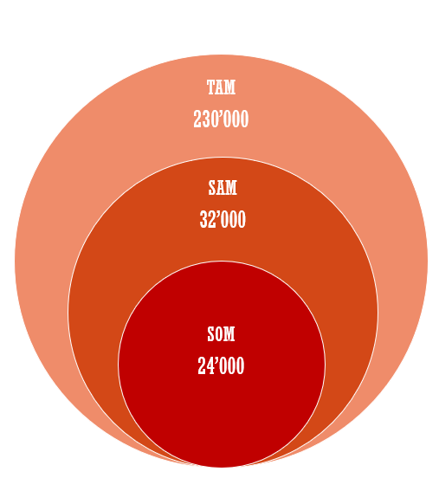

Figure 3 - TAM/SAM/SOM schema

The total amount of possible customers is composed by all university students and high-school students in the city of Milan (230 000). Reasonably we are not talking to all of them, but we must consider the ones attending universities and high schools near our bar, so the number of potential clients should be decreased to these ones and to Catholic University’s students (32 000). Taking into consideration that the available places in the Bar are around 80 and that not all of them are used every day by the same person, we estimate that annually we could reach almost 24 000 clients, which is the 75% of the 32 000 students we are directly talking to.

# **Implementation Roadmap**

For the realization of this project in practical terms, we’ve considered the time needed for the following steps: firstly, the obtaining of all the permissions and funds, secondly the research aimed at finding the right collaborators and finally, the furnishing of the inside spaces and the starting of the market campaign.

Starting from our Business Plan, our first step is going to ask for a loan from the bank, in order to find the necessary funds (from our considerations, we’ll need 250.000€). Once obtained them, we sign a rent contract for the loft we talked above, and start to find all the needed licenses to begin the activity. At the beginning we will work directly in the bar, so we don’t have to hire anyone until the third year.

Taking into account that the average startup time needed for the opening of a Café/Bar is usually around 12 months, it’s reasonable to think that it will take almost a year and a half for our project to get off the ground.

After the opening the hardest and funniest part of the work will begin: to be known by everyone.

For the first months the marketing campaign through the social networks and leafleting will be fundamental. At the beginning we would like to involve Catholic university students in order to make the campaign more powerful, start creating our students’ community, which will become one of BAR-H's strengths, and facilitate the word-of-mouth in the academic places.

The most important goal will be reached in the fifth year, when, thanks to the community of students we have created, another BAR-H will be opened near Politecnico di Milano or Bocconi, with the same purpose.

Our final aim is to create a network of BAR-H's in order to help students in creating their own familiar environments near universities and improving their experiences in Milan.

A more detailed iter for the opening is shown in the next diagram.

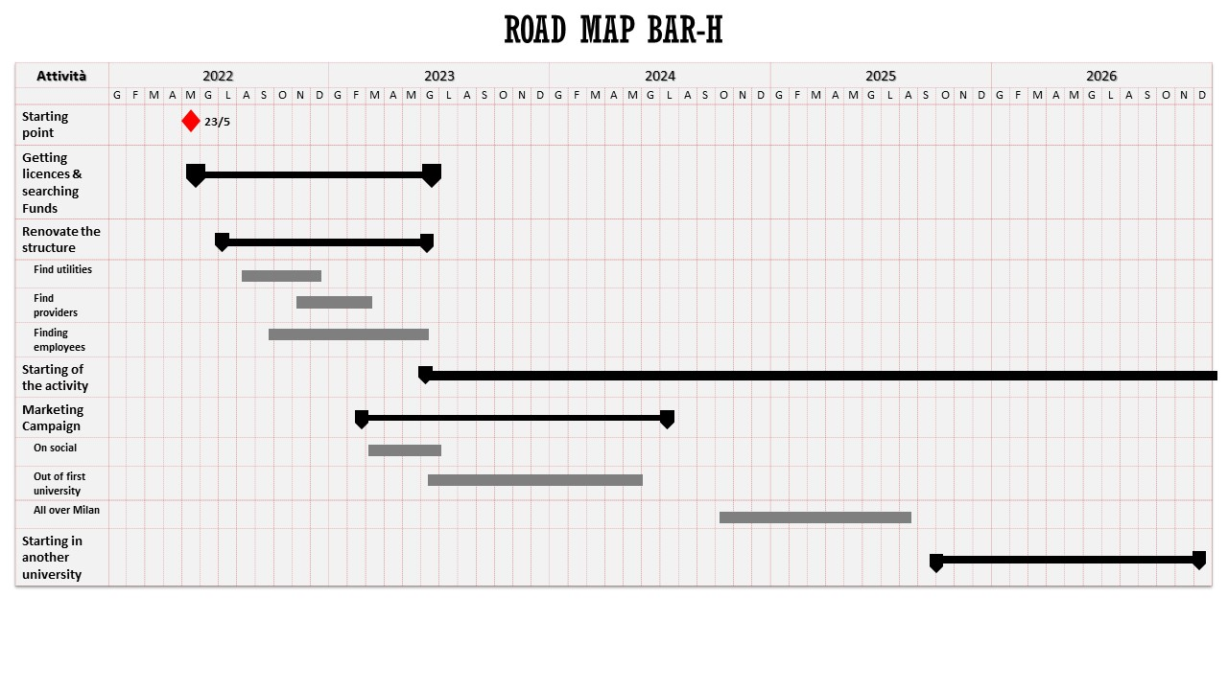

Figure 4 - Gantt's diagram

# **Management Team**

Founders of the Bar-H are represented by us, a Team of four students who are respectively: Paolo Mantovani (22 years old), Giacomo Victor Massari (24), Francesca Mori (22) and Martina Sangiorgi (24).

We are students of Catholic University, currently following the Data Analytics for Business course, who felt the need of creating a new place in order to have a co-working space tailor-made for our studying necessities and also characterized by a familiar feeling.

Each member of the Team has an economic background, Massari e Sangiorgi graduated in Economics and Management while Mantovani and Mori graduated in Economics and Finance; so our team has a really good balance between analytics and management skills which now are deepened in our Master of Data Analysis, a study that allows the learning of fundamental concepts and technical skills, mostly in terms of data acquisition and analysis, which are extremely useful for us in order to collect and to analyze information about our customers’ target with the goal of satisfying their needs in the best way.

So, from many points of view, as it’s possible to deduce, this combination of skills could represent a perfect beginning for our business development.

In terms of working experience, since we are a group of young students, none of us has ever done a direct experience into a company; however, since all of us have always been interested in getting involved into the job’s world, in our small way we have made some attempts.

At first, Massari did a work’s experience into a production company with a role of consulting and making commercials for the company in question; Sangiorgi instead, did an international exchange in England for a summer experience where she has co-worked into a clothes department store and so she had the opportunity to get in touch with different kind of clients.

Mori has participated to a challenge in partnership with Intesa San Paolo known as “Challenge Lab for Future”, aimed at increasing the possibility of hiring staff from students coming from different universities, which could be useful mostly in the personnel selection process; while Mantovani has been the student representative of our Data Analysis course and he also had the opportunity to collaborate in more than one university election campaign in the last years.

So, as it has already been said above, we don’t have so much working experience, but we feel ready to improve and to combine our respectively personal, managerial, and technical skills mostly because we really trust in this project.

Maybe you will ask yourselves “why” we trust it so much, and well basically the answer is that this Business Plan represents us: we are students, and we know what we want and what we need; but most importantly we know a lot of students who study in the Cattolica’s University and from most of them we’ve perceived the same need of having a new place, the right place, not only where to study but also where to feel at home.

Considering the last aspect just mentioned, an important fine for all our Team will properly be creating an informal and familiar environment, aimed above all at welcoming outside students.

This represents a key element for the realization of the Bar-H, and so it is important for us to have a common ideal that united us, in order to carry out this project in the best way at all.

Properly for this reason, in our development perspective we have thought that for the first two years we will directly work into the Bar, so not only in managerial and financial terms but also as waiters, bartenders, cashier and basic events planners.

Then, since in our financial perception we expect to increase the number of clients after the first two years, starting from the third year we would like to extend our team through the recruitment of one additional person as a full-time waiter; and still considering this assumption of growth of our company we expect to hire another one person for a full-time period during the fifth year.

So according to this growth assumption, after the first five years we will extend our Team even more, through the development of a franchising, with the aim of creating this kind of bar near each university located in Milan.

# **Financial Analysis**

To underline the sustainability of our business, we must consider the composition and typology of the costs that we’re going to sustain.

Figure 5 - Costs composition

Our cost model is divided in 4 big macro areas:

1. Labor
2. Renovation
3. Rent
4. Utilities

The biggest percentage of the fixed costs in the early stages are covered by labor (45%), whose cost increases in the following years with the increasing of the revenues, this assuming the growth of the costumers through the years (as shown in the graph).

The reason for this is that, during the first two years of activity, we are not planning to hire any employee to work in the bar, since we have assumed to be able and work in the bar and guarantee normal wages compensated by the return of the initial investment from the third year.

Considering the growth of the costumers and the events organization in the evening, we have decided to hire from 1 to 2 people, in order to assure a complete, caring and accurate service to the customer.

Figure 6 - Labour vs Revenues

Taking into account that we want our place to be student friendly (so it needs to be a young and functional space) and well-equipped (charging points, air recycling and sound-absorbing panels), we assumed that it took us 5 months to renovate the place with a €25.000 of investment.

In terms of renting, each month we must sustain a high cost, around €1.500, without considering the extras costs for final consumption expenditure, considering the location of our bar that is placed into a central location of Milan, extremely close to the Catholic University.

So, assuming a working period of 11 months, the close month will start from the last week of July until the last one of August, considering the exam sessions of our clients; we’ve hypothesized a monthly extra cost of €600 for the necessary expenses, for a total amount of €24.300 for each year.

The main activity of our business is the Bar itself, so we need an initial concrete investment in utilities in order to be able to offer the best products from the very first time. The main part of this investment is divided in:

* What we need to cook and preserve (fridge, cooking station and instruments for cooking).
* Water dispenser, because due to our ethical choice we decided to offer free water and refill, in order to reduce the plastic consumption and to encourage the use of reusable items.
* Tech system for wireless connectivity, an important point from the environmental view, since it guarantees a comfort for the customer and a value added with respect to the competitors. We designed a wireless mesh system for the connectivity that assure a more stable, powerful and secure connection in the whole loft.
* Regarding all the elements that characterize the workspace (working tables and chairs), always considering our ethical, we choose for recycled wood tables large and with a regular surface, and for the chairs some eco-sustainable, comfortable and easy to replace ones, this considering that customers are supposed to used them for long periods of time.

Now, having defined the main fixed costs related to our business, we are going to show the relationship between our costs and our proposed revenues for the first 5 years

Figure 7 - Revenues vs Total Costs

As you can see, our revenue statement is positive compared to all the assumed costs.

But how do we get these revenues?

Besides the monthly revenue received through the classic bar service offered to our future clients, we’ve assumed other sources of revenue:

1. The international happy hour:

From this type of event, that is pretty exclusive for a bar, we expect a good flow in terms of revenues mostly starting from the third year of activity, where we’ll organized it twice a week, as well as in the first two years of activity, but for even more people for each meeting with a proportional number of mother tongue’ teachers, each week.

1. Fees from the organization of tutoring through the partnership with Superprof:

Since we’ll optimize the research and the organization of a tutoring session for our students, and in the same way we’ll bring new customers to the Superprof’s teachers also offering them a comfortable place in our bar; we expect to have a return of a fee for each organized session.

1. Entrees from the room’s renting for group of students:

Given the possibility to reserve our rooms for a pre-defined time period and included in the renting the offer a package with food and drinks based on the considered reserved period, we expect from it to achieve an additional portion of revenues, even if smaller one than others in terms of volume.

1. Evening events: In order to increment at best our revenues, we decided to schedule a series of evening events which, based on our assumptions, will increment our range of clients as well as our revenues. Based on our assumptions and expectations, as you can check in Excel file attachment, these events will represent the first source of our revenues.

Figure 8 - Events Revenues

# **Social/environmental impact analysis**

Our primary goal, from a social point of view, is to create a sense of community among students, which could become in a short time our principal business driver, and a place that allows them to meet new people. The bar would be a reference point also for international students, who could be attracted by the different activities proposed, such as the International Happy Hour or the Quiz Game Night.

As young people and students we want also to be sensible to the environmental sustainability, which implies a bigger effort to reduce as much as possible the energetic and pollutive impact of our activity, and to increase the attention on this important topic and challenge of our time.

To do so, we chose some solutions in this direction:

1. Free refill of still fresh water, as in many coffees and places all around the world, the water as primary good, should not be paid by the customer. Our bar wants to have this view and give people the possibility to use as much water as they want during their stay in the bar. This element has a big sociological aspect, firstly, as the market shows, people are more and more focused on the sustainability (see the increase of using canteens in the last few years), and secondly giving the possibility to self-manage the amount of water, instead of imposing a pre-packed bottle, can make more conscious of their needs.

A more economic and eco aspect is that avoiding the use of plastic/pet/glass bottle reduce the amount of trash of the bar, that it can reduce the cost of local trash tax and the amount of plastics discarded in the environment.

1. Re-Schiscia service: as our main target are students, we want also to be a kind of incubator for students’ ideas, they can use the space as a little world in which create and test their entrepreneurial ideas. Following this vision, we want to host and use a service developed by Politecnico of Milan’ Students (for Anthropology of Communication’s course). This Service allow us to save money on tableware, water, and time. The Re-Schiscia project can be implemented in our bar using their native app and by selling the Re-Schiscia merchandise (which are 100% recycled by using plastic or derivates taken by the ocean).
2. Biova Beer Project selling point: for the aim of sustainability, we want to join also the project coming from a team in Turin that is getting space also in our city. The project came out from a problem and a need, avoid the waste of old/unsold bread by bakeries by reusing it in the process of beer making. As we are talking about a young and well-motivated project that share with us the struggle for environmental sustainability and food waste, we want to be part of it and gave them the possibility to sell their product in our bar also to spread their message as much as possible.



Figure 9 - water dispenser logo

Figure 10 - Biova Project's logo

Figure 11 - Re-Schiscia logo

# **Risk Analysis**

What is the risk related to our activity?

We think that behind this question there is another question: why there is no place like this here in Milan?

The answer may be obvious: no bar or co-working space will focus on students as the main client since usually are not able to spend too much money.

So, if students as first clients represent a high risk, why we’ve decided to open this kind of bar driven by this attitude?

As we’ve already explained above, our project is not focused on the proposal of a common bar, but it is finalized to create a welcoming space that is going to become the point of reference for all the students, firstly from Catholic University and then, for all the other students in Milan, and maybe for all the ones in Italy in few years.

In relation to the customer segment, we can consider a potential risk coming from the periodic division of affluences of the customers to the bar. This depends on the different periods of time that there are in the year for a student. We can divide it in 3 main periods:

1. Classes: this goes, more or less, from September to June (9 months) for highschooler and from September/October to May (8 months) for university students. In this period the affluence in the bar is divided in two: Highschooler may come only in the second half of the day, and this reduces of a half the potential affluence of this part of the customer segment; on the other hand, university students may not come every day, due to the lectures schedule.

For this kind of risk, we may consider that the highschoolers are supposed to take into consideration tutoring sessions (that compensate the marginal loss of the revenues); while for university students is reasonable to consider that the dual mode of the teaching method will remain for at least some periods, and this can ensure that some of the students will remain in the bar and will follow their lessons online from there.

1. Exams: this period is strictly different from university to high school, in high school there’s not a real defined period; it’s more likely that at the end of the quarterly/four-months period there are more exams then during the other days, but we must consider that a high school student will have to study during all the year. This guarantees us that we’ll have a percentage of this students that occupy our spaces.

University students instead, have very well defined schedule for the mid-term exam or the finals (usually from late December – February, late May - July and September for the finals, and late October and late March for the mid-term); considering also that classes usually end before this period is reasonable to state that we will register an increase of customers in the weeks just before and during this period, that can easily compensate any kind of risk during the rest of the year.

Nevertheless, consider that a study session for a university student is generally longer and more likely to start from the early morning and last to the late afternoon and even in the evening, that can be translated into revenues for our business.

1. Holidays: this is the most critical period for the bar (middle of December to first of January, after the middle weeks of July), because there are not classes, this means that is plausible to register a reduction in the affluence of student; we may consider to increase the number of activities during this time, in order to increase the number of extra customers to compensate.

So, our risk will be reduced by all the offered activities which we have thought expressly for our customers’ segment and thanks also to our price’s policy, according to students’ needs, that make us more competitive in this market.

# **Funding**

Referring to the economic component and considering all the financial elements explained above, we thought that a perfect start would be represented by an economic capital of 300.000€.

Obviously since we are four young students, we don’t own all those money and, by joining our budgets, we would be able to invest in this business for a total of 50.000€ only; so, we needed some help to achieve our economic goal.

Taking into consideration all the possibilities, we’ve finally opted for a dept’s funding form: so, for the remaining needed capital of 250.000€ we’ve asked for a loan from a bank.

In order to get this type of loan, we’ve presented to the bank a detailed excel showing our economic perspectives for the first five years from the beginning of our business, focusing on the ending cash balance for each working year, so that we could obtain the necessary trust from the bank convincing it that, thanks to our attitude in this project, we will be able to return our loan regularly.

So given this trust to us, we have signed a contract for a dept of 250.000€, with an expectation of returning in 15 years reasonably based on our economic perspective, starting from the second year of activity, for a total of 16.667€ each year.

So, thanks to this help, our capital will come both from equity, since each component of this team represents a private investor and has the same economic weight, and debt thanks to the big fund returned from a bank which trusted in our business.

Now the question could be “how will you use that money?”

Well, the main investments will be made in the first year divided in the following way:

* At first, it will be necessary a renovation of the rented place at least for a total of 25.000€.
* At second, considering the advance payment asked for the rent (normally required as a guarantee) and in general the total cost that will be incurred in the first 12 months, we’ll sustain a total cost of 24.300€ (taking into account the main consumption costs linked to the environment).
* Third, we’ll need a budget for all the necessary utilities required for our bar, considering the necessary equipment for the kitchen, the necessary furniture designed to best meet the needs of customers for a total of 21.450€.

In addition to this, we had to consider other costs related to the Wi-Fi fee, its maintenance each month, and also the cost related to the SIAE’s license, for a total amount of 1.800€.

Then to all these points, we had to add also the total cost that must be sustained for the creation of a site as a point of reference for our clients and for the App that we would like to develop in order to simplify the use of services like reservations for the organized events, for the rooms and for the seats during the weekend in order to optimize all these aspects through this mean.

Another additional cost will be represented by the marketing, a fundamental aspect mostly for our 2 years of activity, and thanks to the help of the society of “Volantini Milano” we’ll realize 10.000 leaflets which will be monthly distributed around the city, probably only for 9 months for the first two years, for a total amount of 3.384€ for the first two years.

The remining amount we have decided to keep it as a safety margin for any kind of need: starting from a potential reinvestment in furniture to any extreme case of necessity caused by external events and not strictly foreseeable.

**Appendix**

Our future partnerships:

* Superprof - [superprof.it](https://www.superprof.it/)
* Biova beer project - [https://www.biovaproject.com](https://www.biovaproject.com/)
* Re-Schiscia – <https://instagram.com/reschiscia?igshid=YmMyMTA2M2Y=>

What about our fixed costs related to the utilities?

* As we’ve explained our main investment will be sustained in the first year of activity; and part of it will be used for the necessary utilities.

By checking the Excel, in the “Opex simplified”, it’s possible to visualize our costs assumptions.

These assumptions are based on the evaluation of two main aspects:

* What is actually needed in the early stage of the business in terms of utilities: we considered some basic but fundamental equipement for a bar that serves also cooked food and after dinner drinks (fridge, cooker and icemaker)
* In second point, for the economic evaluation we used an average method for all the elements: considering the market prices for all the professional equipment and making an average of that prices

**Index of the Figures:**

[Figure 1 – floorplan of BarH 4](https://unicattolicaicatt-my.sharepoint.com/personal/giacomovictor_massari01_icatt_it/Documents/Business%20Plan.docx#_Toc103692262)

Figure 2 - Customer Archetype 9

[Figure 3 - TAM/SAM/SOM schema 10](https://unicattolicaicatt-my.sharepoint.com/personal/giacomovictor_massari01_icatt_it/Documents/Business%20Plan.docx#_Toc103692264)

[Figure 4 - Gantt's diagram 12](https://unicattolicaicatt-my.sharepoint.com/personal/giacomovictor_massari01_icatt_it/Documents/Business%20Plan.docx#_Toc103692265)

[Figure 5 - Cost's composition 14](https://unicattolicaicatt-my.sharepoint.com/personal/giacomovictor_massari01_icatt_it/Documents/Business%20Plan.docx#_Toc103692266)

[Figure 6 - Labour vs Reveneus 15](https://unicattolicaicatt-my.sharepoint.com/personal/giacomovictor_massari01_icatt_it/Documents/Business%20Plan.docx#_Toc103692267)

[Figure 7 - Revenues vs Total Costs 16](https://unicattolicaicatt-my.sharepoint.com/personal/giacomovictor_massari01_icatt_it/Documents/Business%20Plan.docx#_Toc103692268)

[Figure 8 - Events Revenues 16](https://unicattolicaicatt-my.sharepoint.com/personal/giacomovictor_massari01_icatt_it/Documents/Business%20Plan.docx#_Toc103692269)

[Figure 9 - water dispenser logo 18](https://unicattolicaicatt-my.sharepoint.com/personal/giacomovictor_massari01_icatt_it/Documents/Business%20Plan.docx#_Toc103692270)

[Figure 10 - Biova Project's logo 18](https://unicattolicaicatt-my.sharepoint.com/personal/giacomovictor_massari01_icatt_it/Documents/Business%20Plan.docx#_Toc103692271)

[Figure 11 - Re-Schiscia logo 18](https://unicattolicaicatt-my.sharepoint.com/personal/giacomovictor_massari01_icatt_it/Documents/Business%20Plan.docx#_Toc103692272)